The President
EUROPEAN SOCIETY OF HOSPITAL PHARMACISTS
c/c Dr. Ana Valladolid, Dr. María José Tames, Dr. Eduardo Echarri

Madrid – April 26, 2016

Dear colleague:

We are hereby submitting the update of the Code of Ethics for Pharmacists now revised from the former 1998 version to the Executive Board which you preside so that you may analyze and subscribe the same, should you so deem fitting, as our Spanish National Society of Hospital Pharmacists (SEFH) has already done.

Subscribing this Code, on whatever certificate may be befitting, means that pharmacists, on one hand, and the society as a whole, on the other, have knowledge of a reference Code of Ethics which pharmacists take upon themselves as their own, because there is much more uniting us than dividing us concerning the field of Pharmacy, regardless of geographic location and the area in which we work.

The professionalism of being pharmacists is our hallmark uniting us in striving for excellence with a commitment to responsibilities and duties, regardless of the area in which we are carrying out our work in the field of pharmacy.

For the time being, this code has been subscribed by the International Organization of Iberian and Latin American Pharmacists (OFIL), the Spanish Association of Pharmaceutical Analysts, the Spanish Association of Social Pharmacists, the Spanish Society of Rural Pharmacists, the Spanish Society of Hospital Pharmacists, the Navarre Society of Hospital Pharmacists, the Aragon Society of Hospital Pharmacists, and the Castile-La Mancha Society of Hospital Pharmacists.

We shall be looking forward to hearing from you.

Best regards,

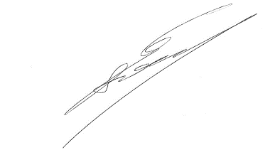

Enrique Soler Company Dolores Barreda Hernández
ETHOS Group Coordinator Coordinator of the Code of Ethics for Phamacists
soler_enrcom@gva.es dbarreda@sescam.org

