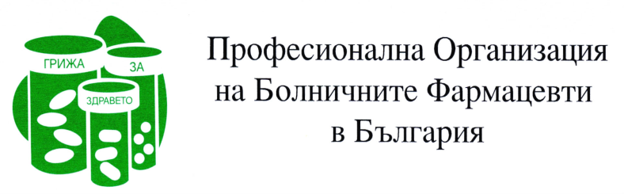

BULGARIAN ASSOCIATION OF HOSPITAL PHARMACISTS

COUNTRY REPORT 2021

1.XV National Conference of Hospital Pharmacy – October 2021

- The main topic during the conference was again the pandemic of COVID 19 and the participation of hospital pharmacists in the fight against the disease. Ministry of health has lecture about treatment with Remdesevir in our country. The state of verification of medicinal products in Bulgaria was presented also.
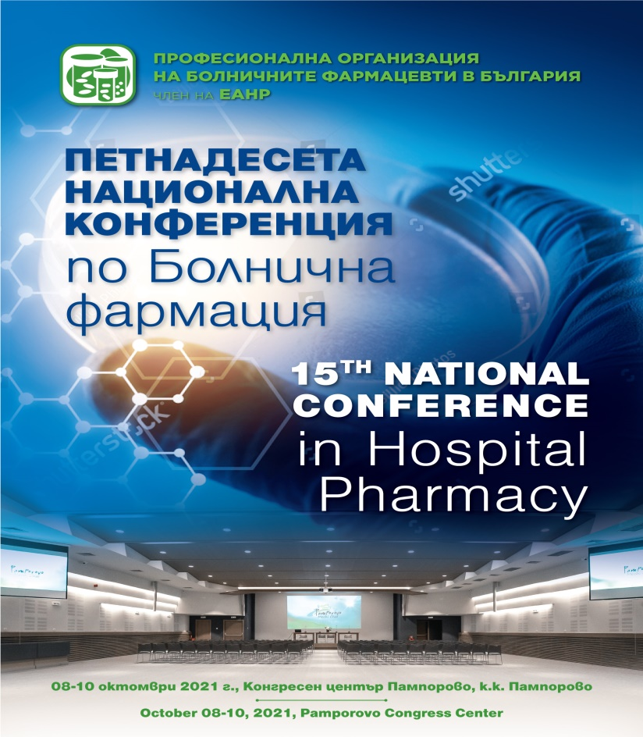

All anti-epidemic measures were observed during the events

2. First National Student Competition „Become a hospital pharmacist”

Students from 4 of the five faculties of pharmacy in Bulgaria took part. The questions were from the fields: pharmacology and pharmacotherapy, pharmaceutical regulation and practical part.



