cmLead – Advanced Lead Retrieval for Exhibitors
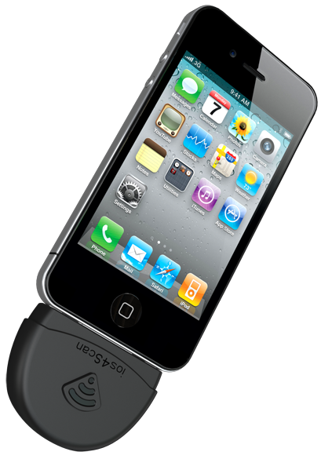

Before the Conference
- Order COVR Lead Retrieval Services through the conference website.
- You have the possibility to order the cmLead Application with an
iPod Touch or an iPad.
- Your order includes the rental of a state of the art barcode scanner
that can be plugged into your iPod Touch or iPad and guarantees
the highest possible performance in barcode scanning.
- After receiving your order, we will send you a username & password by e-mail to login to the cmLead portal as well as an activation code to activate the cmLead app.
You will also receive a user manual with a step-by-step explanation of how to use the cmLead portal & App before, during & after the conference.

Before & DURING the Conference
- Once you are logged in to the cmLead portal, you can start setting up your qualifiers (products, services …).
- The onsite Covr crew will make sure your qualifiers and all delegate information are available on your iPod Touch or iPad.
- Your qualifiers and delegate database will automatically be synchronized onsite.
(provided the device has Wi-Fi / data access)
- Your qualifiers can be updated at any time.

DURING the Conference
- After having entered the activation code, the device is ready for use!
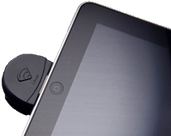
- No Wi-Fi / data is needed for the actual scanning onsite.
- After scanning a badge you will see all available delegate data on
your device.
- If needed, you can add more data or even make changes
to the presented delegate data.
- For each scan you can select your qualifiers and
additional comments.
- You remain in full control of all your scanned leads.
At any moment you can display any scan you made with your device and make changes.
- Lead data will be synchronized continuously with cmLead Server if Wi-Fi / data is available.
- At the end of the conference you return the barcode scanner as well as the iPad or iPod Touch.

DURING & AFTER the Conference
- Once you synchronized all your leads with the cmLead portal you can:
- export them from the portal and
- start using the information gathered to optimize your sales efforts.
- Your lead data will remain available on the cmLead portal after the conference for
6 weeks.

Terms, Conditions & Pricing

Order deadline - After the ordering deadline of 07/03/2014, COVR does not accept orders automatically but will confirm acceptance upon availability. For confirmed orders after 07/03/2014 a surcharge of €100,00 per device will be added.

- Rental rates are per cmLead Set and include a high performance barcode scanner (iScan), an iPod Touch or an iPad and the cmLead software with an unlimited number of scans.

- Terms of payment - Upon receipt of order, an invoice representing the total amount due (quoted prices are net excluding Belgian VAT of 21%) will be sent by COVR. Payment has to be done by credit card via Ogone after you’ve placed the order online.

- Cancellation - Orders can be cancelled until 07/03/2014 without any fees. After 07/03/2014 there is a cancellation fee of 50%.

- Pick up/Return — The rented equipment must be collected at the exhibitors’ desk on Wednesday 26 March 2014, between 07:00 and 12:00 Hours and returned on Friday 28 March 2014, before 14:00 hours. Exhibitors are responsible for the proper use and safe keeping and will pay for any damage occurred during the rental.

Items failed to be returned onsite must be sent by courier to COVR bvba (Oude Tramstraat 5, 2490 Balen, Belgium) within 5 working days after the last day of conference. The cost of lost, damaged or not completely returned hardware will be €500,00 per scanner, €300,00 per iPod Touch and €1.000,00 for an iPad.

- Data retrieval and protection
Each lead will contain the contact information as provided by the participant or the group registration contact person on the registration form (name, full address, telephone, fax, email and lead codes). Hence the quality of the delegates’ contact details – collected by the organizer - will ultimately define the value of the lead retrieval system. Neither EAHP nor COVR can be held liable for incorrect data.

The company renting the scanners hereby agrees to respect the data privacy policy imposed by EAHP. The cmLead application will however, display the available info immediately after scanning and give you the opportunity to complete the data on the spot.

- Pricing

 | Orders before  21/02/2014 | Orders between 22/02/2014 & 07/03/2014 | Units | € Total
Rental of cmLead software + iScan + iPod Touch | € 450 | € 550
Rental of cmLead software + iScan + iPad | € 700 | € 800
Rental of symposium scanner (2hrs rental) | € 350 | € 450
Cancellation fees | 0% | 50% | Total €
Prices excl. 21% Belgian VAT.
Please use the following link to place your order:
www.covr.be/cmlead/eahp19.aspx
Orders can only be placed online and require online credit card payment.
After acceptance of your order, COVR will send you a confirmation and invoice.

